Market Monitor - Bangladesh - 2026-05

Highlights
The Bangladesh market exhibited significant volatility in May, with sharp price drops in key staples like onions and chickpeas offsetting a major surge in egg prices. Overall food costs remained relatively stable month-on-month despite the underlying turbulence, while the BDT remained stable against the USD.
The cost of a typical food basket increased slightly by 0.6% from April but remains 9.2% lower than a year ago.
Key Commodity Price Movers (MoM):
- Onions (imported, China): ↓23.6%
- Eggs (brown): ↑16.1%
- Chickpeas: ↓17.0%
Key Drivers:
- A sharp monthly price surge in eggs (↑16.1%) drove inflation in animal protein costs, even as broiler chicken prices decreased (↓3.8%).
- Significant price drops for key staples, notably imported onions (↓23.6%) and chickpeas (↓17.0%), provided relief to consumers and countered overall inflation.
- Persistent year-on-year inflation in specific items, such as dry chili (↑31.0%), indicates ongoing supply-side pressures for certain commodities, contrasting with the broad annual deflation in the food basket.
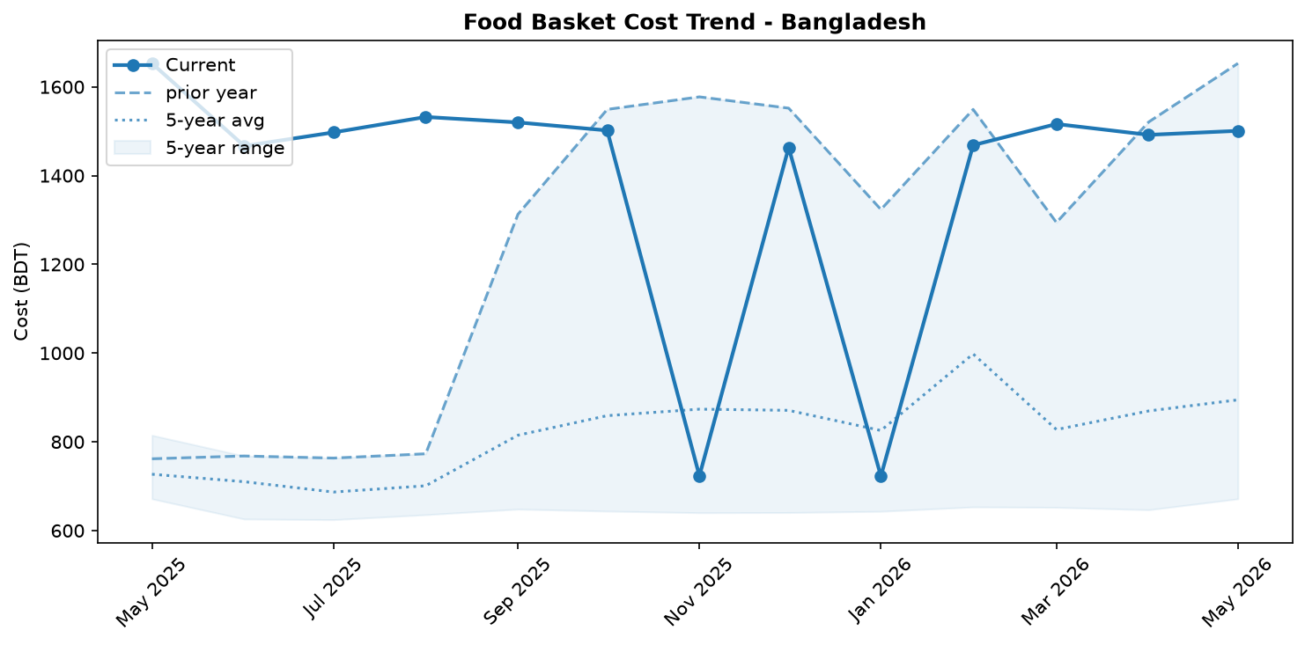
Food basket cost trend

Market Overview
The Bangladeshi market in May 2026 was characterized by significant volatility, with powerful inflationary and deflationary forces creating a turbulent pricing environment. While the overall national food basket remained relatively stable with a minor 0.6% month-on-month increase, this figure masks extreme price movements within key commodity groups. The market's trajectory is being pulled in opposing directions by two primary trends: first, a dramatic inflationary surge in essential animal products, most notably milk and eggs; and second, a sharp deflationary drop in the prices of other staples, including onions and chickpeas. This push-and-pull dynamic is further complicated by diverging fuel prices. A decrease in the cost of diesel offers potential relief for production and logistics, but a simultaneous sharp increase in petrol prices is set to raise transportation costs for consumers and businesses. The recent stability of the Taka against the US dollar has helped temper the cost of imports, but the market's short-term outlook remains unpredictable. The prevailing trend in the coming month will depend on whether the inflationary momentum from dairy and fuel can overpower the strong deflationary pressures from other core food items.

Commodity Analysis
May's commodity price movements revealed a deeply divided market. The livestock sector experienced the most significant shock, with milk prices surging by an unprecedented 67.0% month-on-month, placing it in a state of high inflation with a 68.8% year-on-year increase. This has severely impacted household access to dairy. Similarly, egg prices jumped 16.1% from April, a significant short-term hike for consumers, though prices remain 33.2% below last year's levels. In stark contrast, several key staples provided significant price relief. Imported onions and chickpeas acted as a strong deflationary force, with their prices falling by 23.6% and 17.0% month-on-month, respectively. Meanwhile, some items continued on a persistent inflationary path; the price of Indian Teja dry chili rose another 3.1% MoM, marking a substantial 31.0% increase year-on-year and indicating ongoing supply constraints. The fuel market mirrored this divergence. Diesel, crucial for agriculture and freight, became 2.1% cheaper, potentially lowering food production costs. However, petrol prices climbed 9.6%, directly increasing transport costs for a large segment of the population and creating mixed pressure on overall food affordability.
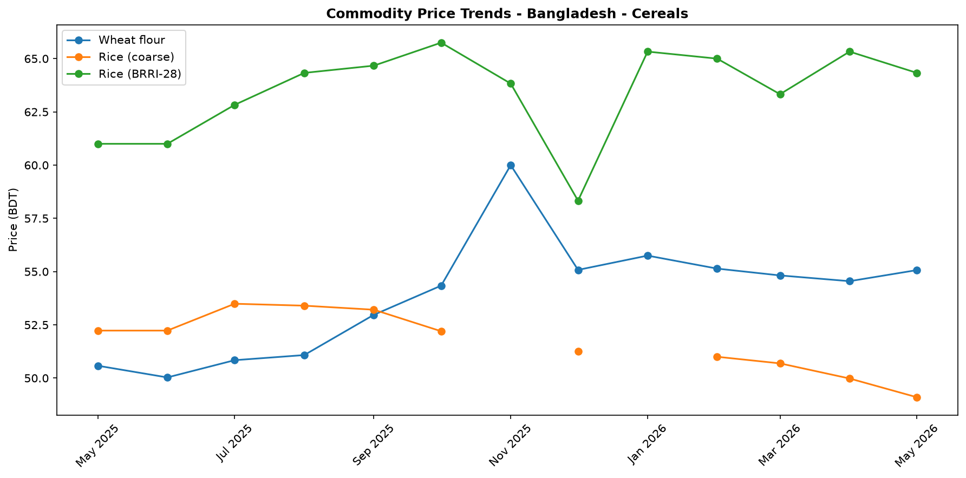
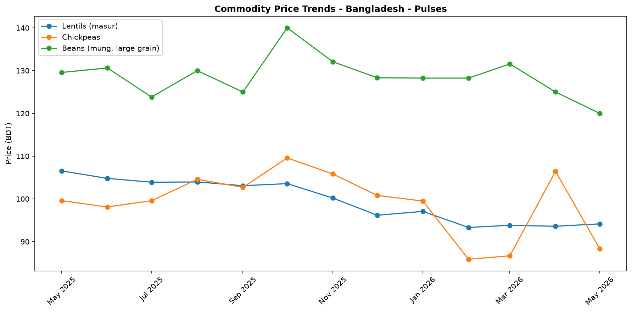
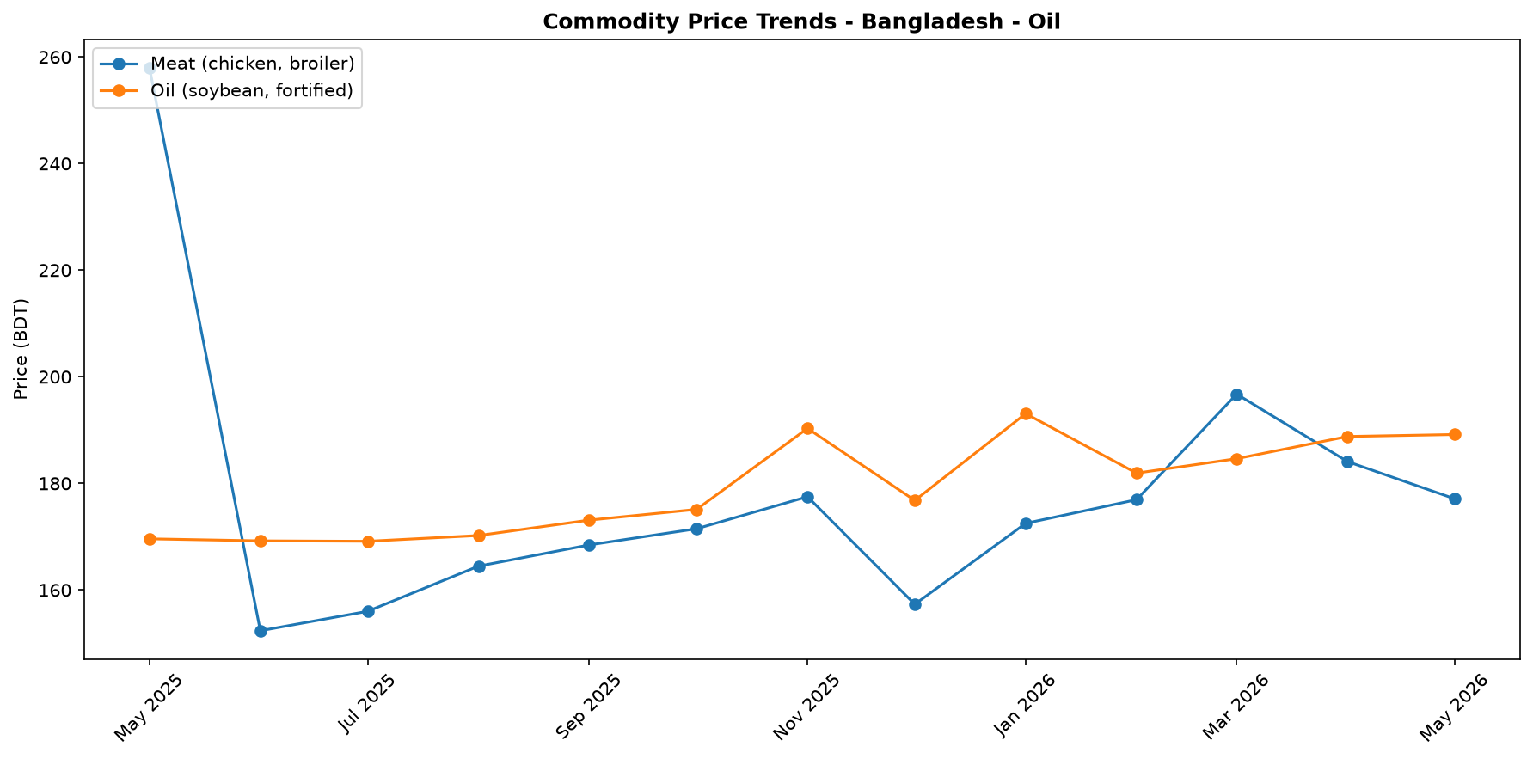
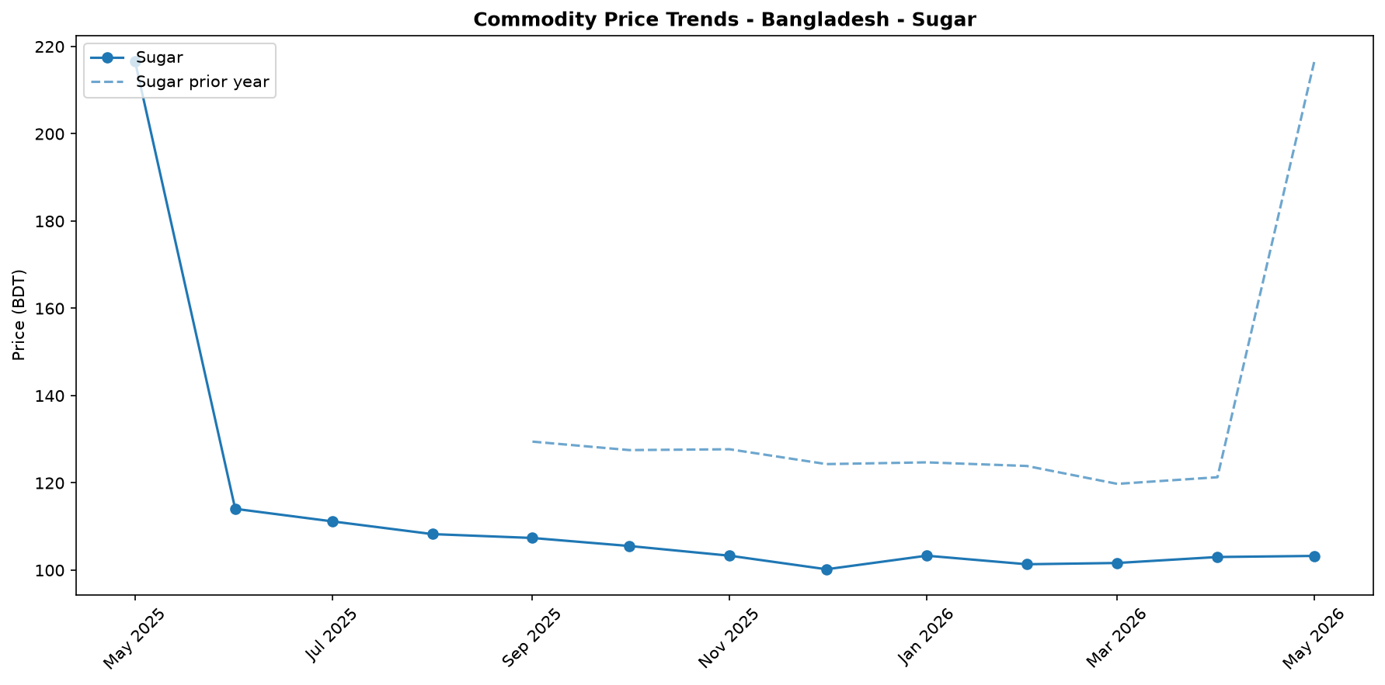
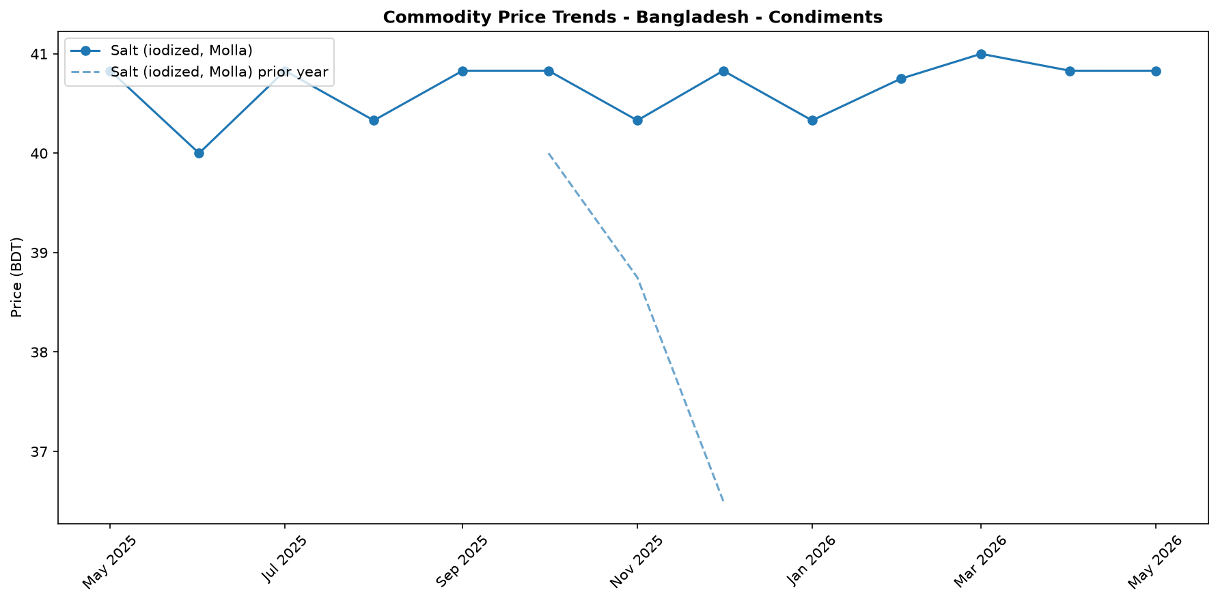
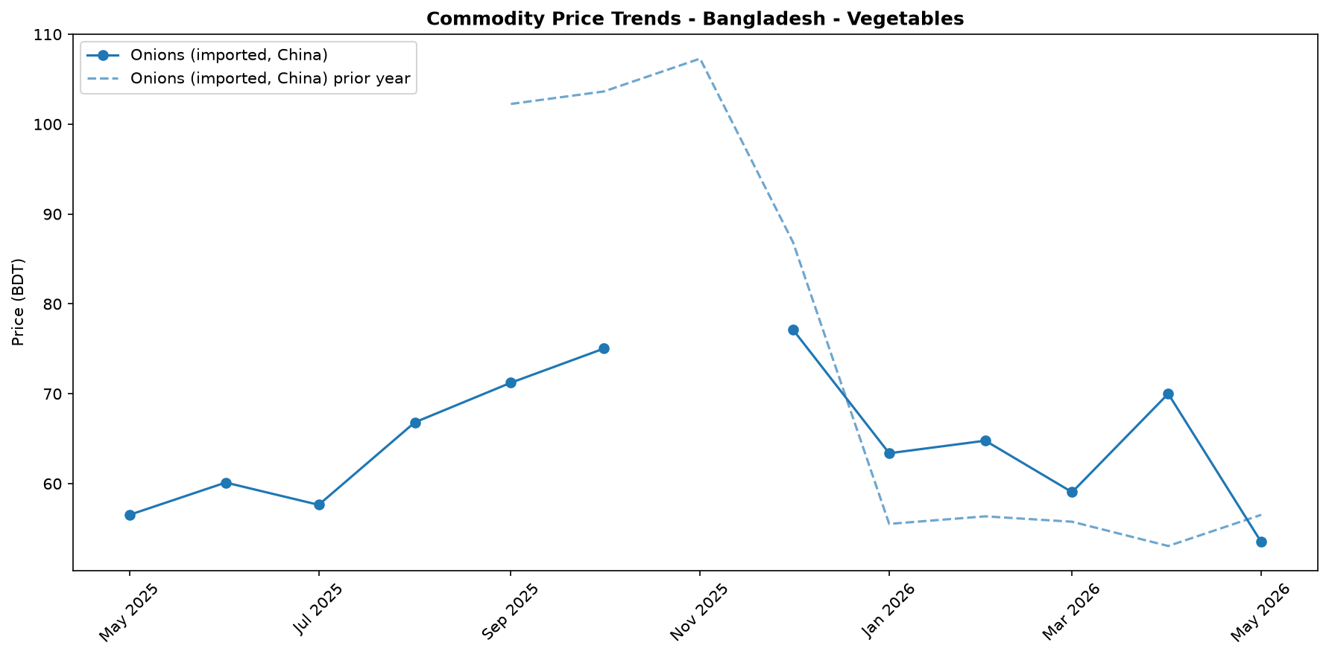
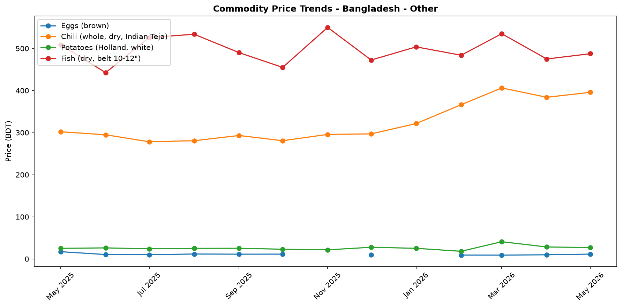

Regional Highlights
Regional price analysis reveals notable market fragmentation, particularly in the livestock sector. Data for broiler chicken shows a significant price disparity, with the average price in the Khulna region (191.08 BDT/kg) standing 16.6% higher than in the Mymensingh region (163.91 BDT/kg). This substantial gap suggests the influence of localized factors, such as varying supply chain efficiencies, regional demand patterns, or disparate logistics and transportation costs. While insufficient data prevents a broader commodity analysis across all regions, this disparity underscores the importance of monitoring sub-national market dynamics. Localized economic conditions, such as those in refugee-hosting districts like Cox's Bazar, can further influence regional price trends. These areas face unique pressures, including large-scale humanitarian aid appeals and environmental challenges like deforestation, which can impact local economies and supply chains. Understanding these regional variations is critical for a complete picture of market performance and food security across Bangladesh.
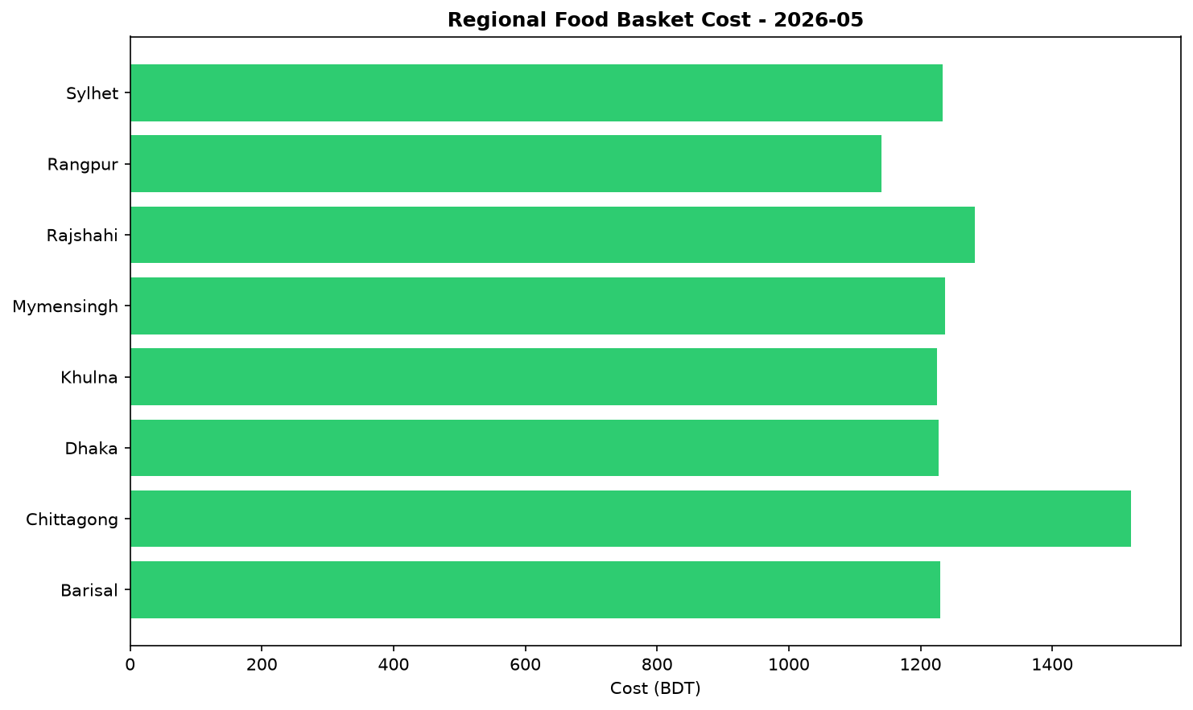

Exchange Rate Analysis
The Bangladeshi Taka (BDT) remained stable, trading at 122.75 per US dollar. A marginal month-on-month depreciation of 0.04% had a negligible effect on the cost of imports. However, a year-on-year comparison reveals a 0.45% depreciation, indicating a slight but persistent weakening trend over the longer term. This recent stability helps contain immediate price shocks for imported essential commodities such as wheat, cooking oil, and fuel, which are crucial for food security. Nonetheless, the gradual annual depreciation continues to exert modest upward pressure on the domestic prices of these goods. The stability is a positive factor for short-term price predictability, but the long-term depreciation trend remains a point of concern for the affordability of imported food and fuel.

Fuel & Energy
In May 2026, the national average retail price of diesel decreased by 2.1 percent to BDT 120.25 per litre, while petrol increased by 9.6 percent to BDT 145.25 per litre; both fuels remained higher year-on-year by 7.1 percent and 11.6 percent, respectively. This price divergence is likely consistent with adjustments to the country's administered pricing mechanism. While the lower cost of diesel, the primary fuel for goods transport and agriculture, may ease food price inflation by reducing distribution costs, the sharp increase in petrol prices will likely raise transport costs for many households and businesses, creating mixed pressure on food prices and purchasing power.
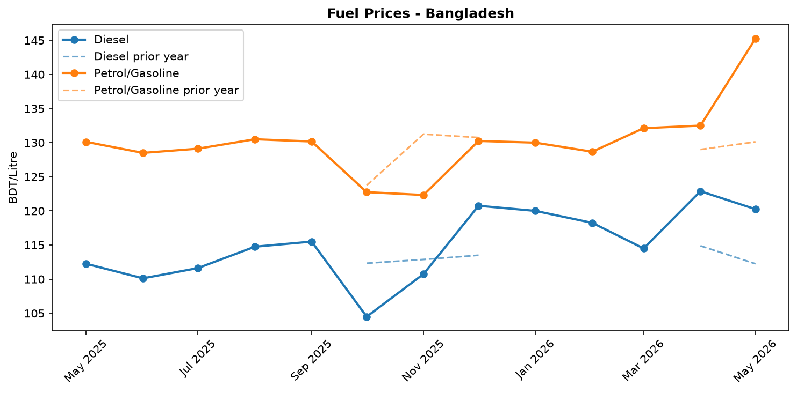
Fuel retail price trend

Livestock & Animal Products
In May, prices for key animal products diverged sharply, with milk surging 67.0 percent month-on-month to BDT 202.5 per litre and eggs increasing by over 15 percent, while beef and broiler chicken prices eased by 8.5 and 3.8 percent, respectively. The increases are consistent with significant inflationary pressure noted in the market, whereas the meat price declines are likely due to easing demand or improved supply. The dramatic rise in milk and egg prices is significantly impacting household budgets and reducing access to these proteins, even as lower meat prices offer some relief, with broiler chicken prices also showing a notable 16.6 percent spread between the Khulna and Mymensingh regions.
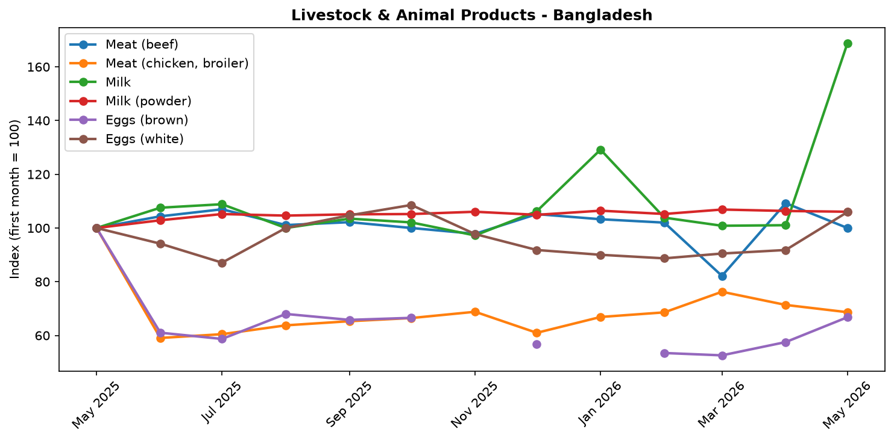
Livestock and animal product price trend

References
- [rw_4214182] ReliefWeb (2026-05-31) Finland boosts support for Rohingya refugees with EUR 2 million contribution [EN/BN]
https://reliefweb.int/node/4214182
- [rw_4214118] ReliefWeb (2026-05-29) Period poverty: A global menstrual health crisis
https://reliefweb.int/node/4214118
- [rw_4213869] ReliefWeb (2026-05-28) Asia and the Pacific: Weekly Regional Humanitarian Snapshot (19 - 25 May 2026)
https://reliefweb.int/node/4213869
- [rw_4213682] ReliefWeb (2026-05-26) Homestead Gardening Guidelines - Vegetable production for household consumption using minimal space in Rohingya camps and host communities
https://reliefweb.int/node/4213682
- [rw_4212820] ReliefWeb (2026-05-20) UN and partners appeal for USD 710.5 million to meet the critical needs of Rohingya refugees and Bangladeshi host communities [EN/BN]
https://reliefweb.int/node/4212820
- [rw_4212682] ReliefWeb (2026-05-19) From coverage to prioritisation: how funding cuts are reshaping operational decisions in Cox’s Bazar
https://reliefweb.int/node/4212682
- [rw_4212292] ReliefWeb (2026-05-15) Impact of gardening and nutrition support provided to women in refugee camps in Cox’s Bazar
https://reliefweb.int/node/4212292
- [rw_4212129] ReliefWeb (2026-05-14) Mr. Tom Fletcher, Under-Secretary-General for Humanitarian Affairs and Emergency Relief Coordinator – Remarks to the press on US humanitarian funding at UN Headquarters, 14 May 2026
https://reliefweb.int/node/4212129
- [rw_4212067] ReliefWeb (2026-05-14) Sweden announces more than SEK 2.7 billion in humanitarian assistance to the world’s most vulnerable
https://reliefweb.int/node/4212067
- [rw_4211766] ReliefWeb (2026-05-13) UNHCR Regional Bureau for Asia and Pacific: Myanmar Situation Update (Bangladesh, India, Indonesia, Malaysia, Myanmar, and Thailand) January - March 2026
https://reliefweb.int/node/4211766
- [seerist_1028666] Seerist (2026-05-22) Tiger kidnaps to remain rare despite incident involving bank manager in Dhaka district
- [seerist_1028464] Seerist (2026-05-08) Big Picture series: Keep calm and kharif on – fertiliser shock and political risk in South Asia
- [seerist_1028203] Seerist (2026-04-17) Operational, integrity risks to persist in renewable energy sector despite government support
- [seerist_1028169] Seerist (2026-04-16) Political interference, integrity risks likely to remain prevalent in banking sector despite reforms
- [seerist_1028140] Seerist (2026-04-14) Uneven enforcement of new labour law will sustain reputational, unrest risks in manufacturing
- [seerist_1028118] Seerist (2026-04-13) Big Picture series: Asian economies face prolonged energy stress as Middle East disruption persists
- [seerist_1028051] Seerist (2026-04-07) Civil unrest risks to increase amid differences over political reforms

